**Cilindervoering meten.**

* Meten met cilindermeetklok.
* Meet de cilinderboring op drie plaatsen en haaks op elkaar zoals aan gegeven in het figuur met behulp van A en B.
* Maximale afwijking van de standaard maat: 0,08 mm

|  |  |  |  |
| --- | --- | --- | --- |
| Cilinder 1 | Cilinder 2 | Cilinder 3 | Cilinder 4 |

A A A A

B B B B

**1 1 1 1**

**2 2 2 2**

**3 3 3 3**

|  |  |  |  |
| --- | --- | --- | --- |
| 1A | 1A | 1A | 1A |
| 2A | 2A | 2A | 2A |
| 3A | 3A | 3A | 3A |

|  |  |  |  |
| --- | --- | --- | --- |
| 1B | 1B | 1B | 1B |
| 2B | 2B | 2B | 2B |
| 3B | 3B | 3B | 3B |

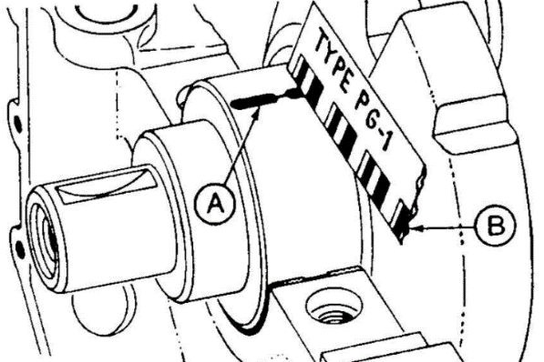**Krukas lagertappen.**

* Meten met micrometer
* Vet vrij
* Meten in axiale en radiale richting
* Zijkant lagertap, dus per richting 2 metingen

**hoofdlagertappen**

|  |  |  |  |  |
| --- | --- | --- | --- | --- |
| 1 | 2 | 3 | 4 | 5 |

A A A A A

B B B B B

|  |  |  |  |  |
| --- | --- | --- | --- | --- |
| A l | A l | A l | A l | A l |
| B l | B l | B l | B l | B l |
| 0 l | 0 l | 0 l | 0 l | 0 l |

**Drijfstanglagertappen**

|  |  |  |  |
| --- | --- | --- | --- |
| 1 | 2 | 3 | 4 |

A A A A

B B B B

|  |  |  |  |
| --- | --- | --- | --- |
| A l | A l | A l | A l |
| B l | B l | B l | B l |
| 0 l | 0 l | 0 l | 0 l |

**Buitendiameter zuiger.**

* Meten met de schroefmaat
* Zuiger haaks op de zuigerpen meten
* Op drie punten meten (hartlijn, onderkant zuigerveren, onderkant zuiger)

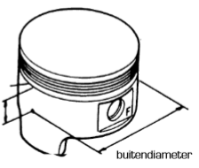

1

2

3

|  |  |  |  |
| --- | --- | --- | --- |
| Zuiger 1 | Zuiger 2 | Zuiger 3 | Zuiger 4 |
| 1 | 1 | 1 | 1 |
| 2 | 2 | 2 | 2 |
| 3 | 2 | 3 | 3 |

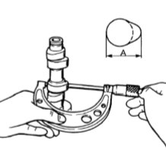 **Nokhoogte**

* Meten met de schroefmaat.

**Inlaatnokken**

|  |  |  |  |  |  |
| --- | --- | --- | --- | --- | --- |
| **l** | **l** | **l** | **l** | **l** | **l** |

**Uitlaatnokken**

|  |  |  |  |  |  |
| --- | --- | --- | --- | --- | --- |
| **l** | **l** | **l** | **l** | **l** | **l** |

**Diameter nokkenassen**

* Meten met schroefmaat

**Inlaatnokken**

|  |  |  |  |  |  |
| --- | --- | --- | --- | --- | --- |
| **l** | **l** | **l** | **l** | **l** | **l** |

**Uitlaatnokken**

|  |  |  |  |  |  |
| --- | --- | --- | --- | --- | --- |
| **l** | **l** | **l** | **l** | **l** | **l** |

**Vlakheid.**

* Meten met de rei
* Meten met lamp
* Meten met Voelermaatje
* Meten op 5 verschillende plekken

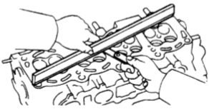

1 2 3 4 5

|  |  |  |  |  |
| --- | --- | --- | --- | --- |
| 1 | 2 | 3 | 4 | 5 |

**Radiale klepspeling.**

* Meten met meetklok met statief
* Klep iets omhoog halen en heen en weer bewegen.

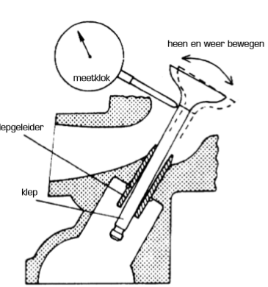

**Inlaatklep**

|  |  |  |  |
| --- | --- | --- | --- |
| Cilinder 1 | Cilinder 2 | Cilinder 3 | Cilinder 4 |
| **l** | **l** | **l** | **l** |

**Uitlaatklep**

|  |  |  |  |
| --- | --- | --- | --- |
| Cilinder 1 | Cilinder 2 | Cilinder 3 | Cilinder 4 |
| **l** | **l** | **l** | **l** |

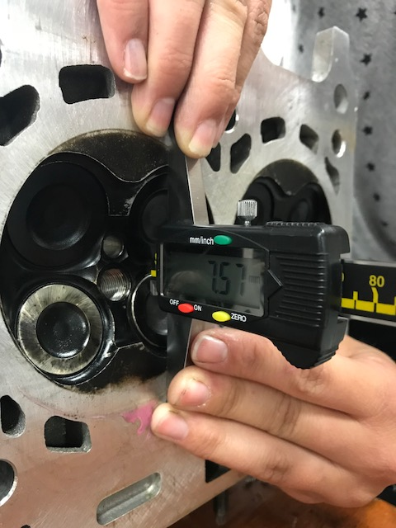**Klepdiepte.**

* Meten met digitale dieptemeter
* Meten op het laagste gedeelte van de klep

**Inlaatklep**

|  |  |  |  |  |  |
| --- | --- | --- | --- | --- | --- |
| Cilinder 1 | Cilinder 2 | Cilinder 3 | Cilinder 4 | Cilinder 5 | Cilinder 6 |
| **l** | **l** | **l** | **l** | **l** | **l** |

**Uitlaatklep**

|  |  |  |  |  |  |
| --- | --- | --- | --- | --- | --- |
| Cilinder 1 | Cilinder 2 | Cilinder 3 | Cilinder 4 | Cilinder 5 | Cilinder 6 |
| **l** | **l** | **l** | **l** | **l** | **l** |

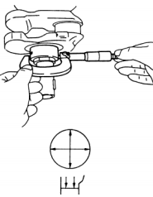**Diameter lager nokkenassen.**

* Meten met schroefmaat

A

B

**Lager inlaat**

|  |  |  |  |  |  |
| --- | --- | --- | --- | --- | --- |
| A1 | A2 | A3 | A4 | A5 | A6 |
| B1 | B2 | B3 | B4 | B5 | B6 |

**Lager uitlaat**

|  |  |  |  |  |  |
| --- | --- | --- | --- | --- | --- |
| A1 | A2 | A3 | A4 | A5 | A6 |
| B1 | B2 | B3 | B4 | B5 | B6 |

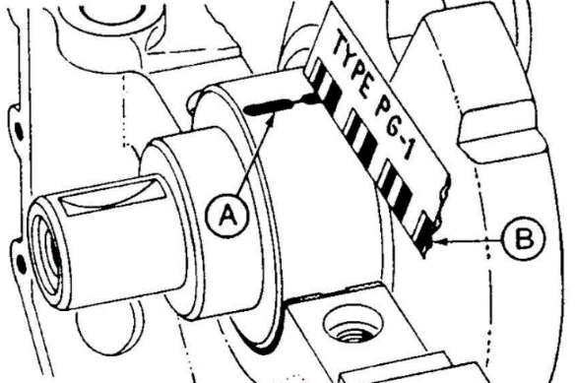**Speling nokkenas lager (radiaal)**

* Meten met platigage
* Vet vrij
* 10 nm

**Lager inlaat**

|  |  |  |  |  |  |
| --- | --- | --- | --- | --- | --- |
| A1 | A2 | A3 | A4 | A5 | A6 |

**Lager uitlaat**

|  |  |  |  |  |  |
| --- | --- | --- | --- | --- | --- |
| A1 | A2 | A3 | A4 | A5 | A6 |

**Grondboring**

* Nokkenas lager + speling nokkenas lager = grondboring

……..… + ………. = ….……

**Speling nokkenas lager (axiaal)**

* Meten met het meetklokje op statief
* 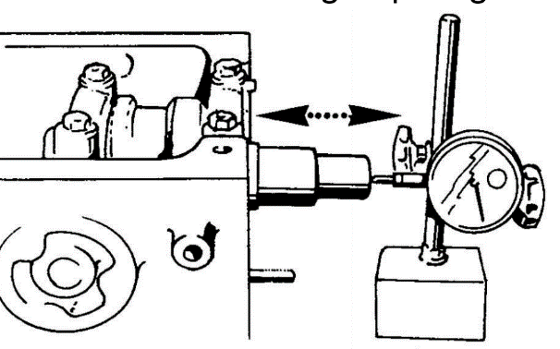Nokkenas heen en weer bewegen

Speling = ……..